# MyDrive Android Mobile App

## Overview

This app could be used as a proxy for the vehicle sensor and can report the following to IoT FM Cloud using the android accelerometer and GPS sensors.

* Location
* Speed
* Engine ON Time
* Odometer
* Harsh Acceleration
* Harsh Braking
* Harsh Cornering
* Excessive idling (along with the time in idling)
* Overspeeding (along with the distance covered while in overspeeding)

Additionally, the app could also simulate the cargo device (as if one is attached to the vehicle) using the temperature, humidity, light etc sensors which may be present in the mobile device (these sensors are mobile device specific).

This is NOT a driver dashboard app but rather an app that acts as the sensor installed on the vehicle (much like an OBD sensor). The existing IoT FM Mobile app is used by the drivers to start/complete a trip etc.

Note : For using the app, one needs to follow certain things. Needless to say this has been built over weekends ☺ and I may work on improving those aspects later. The main intention of this app is to provide a POC for how a mobile phone could be used a vehicle sensor device (not only for GPS but other aspects such as driver behavior monitoring) and use it to test IoT FM Cloud with real usage data.

## How to use the app

Here are the steps to use this app.

### IoT FM Cloud Setup

* Import the provided IoT Device Models (MyDriveMobileDeviceModel.json and CargoMonitoringDeviceModel.json) into the IoT Cloud instance and include these device model in the IoT FM application. These two device models are for the vehicle sensor and the cargo sensor devices.

*Note: These device models are included in this document towards the end.*

* Register a device for each of these device models and download those 2 provisioning files.
* Create a Vehicle Type in IoT FM. Choose the following sensor attributes from the default list provided…
  + Speed
  + Odometer

Add the following sensor attributes to the vehicle type

* + CargoTemperature
  + CargoHumidity
  + CargoLight
  + CargoPressure
  + CargoProximity
* Associate the corresponding device models to this vehicle type.

### MyDrive Mobile App Setup

* Upload the 2 provisioning files to a folder on your mobile device e.g. Download folder.
* Download the app from [this location](https://oradocs-corp.documents.us2.oraclecloud.com/documents/link/LDA2F09314A635CF829D74C7F6C3FF17C1177A968060/fileview/D09F88FDD19995EAB634844BF6C3FF17C1177A968060/_MyDrive.apk).
* Install the app on your android mobile device by using the provided apk file.

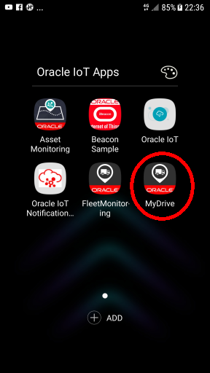

* Based on the cloud instance you are connecting to, you may need to turn on VPN on your mobile. So far I have only tested this over VPN by connecting it to a dev instance and not by connecting to an external cloud instance.
* When you launch the app for the first time, it will ask for certain permissions. Please grant those.
* It may ask you to turn ON the GPS in your phone, if not already.

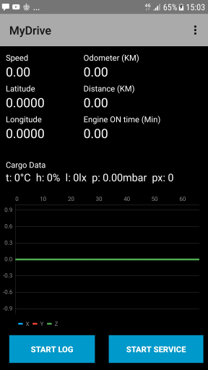

* Click the settings icon on top right. Yes, those 3 dots.

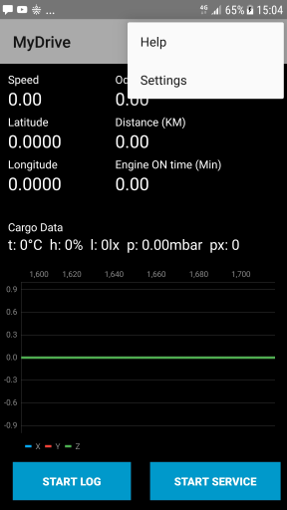

* Click on Settings menu item

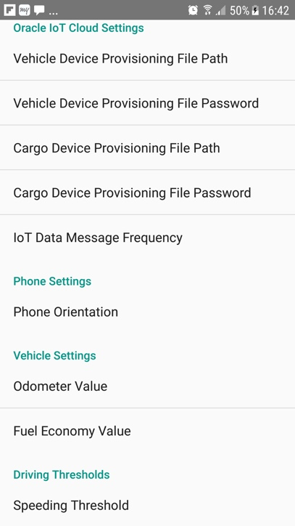

* In the Oracle IoT Cloud Settings section, fill in the path of the provisioning files and their passwords.

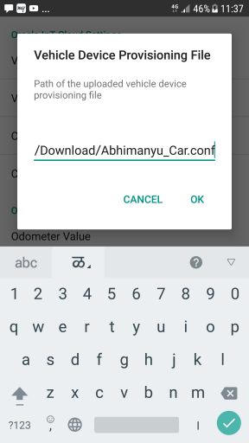

* In the phone settings section, choose the orientation of phone i.e. how you would keep the phone when using it in your car - either portrait or landscape orientation

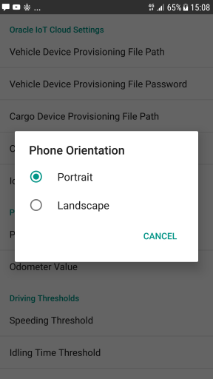

* In the Vehicle Settings section,sSet the Odometer value to the one shown on your actual car odometer. If you don’t set it, then it is okay too. It will start the odometer from 0.

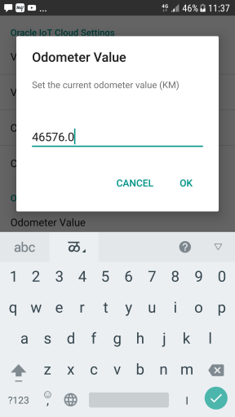

* Set the Fuel Economy value to that of your vehicle. This is used for calculating the fuel used by the vehicle.
* Set Driving Thresholds appropriately. While the Speeding Threshold is a value in KMPH and the Idling Time Threshold is in Minutes, the Maneuvering Acceleration Threshold is in m/s^2. Alternatively, you could just use the default values for these settings.
* Click on the Start Service button.

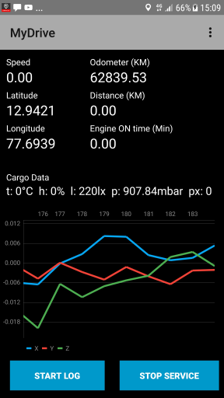

* The app starts a foreground service. See a small notification icon in the top left corner on the notification bar. The app screen shows the Speed, Location, Odometer, Distance and Engine ON time. The chart shows the acceleration values on 3 axes.
* You could kill the main app but the service still keeps on running. You can see that the service is still running by pulling down on the notifications bar.

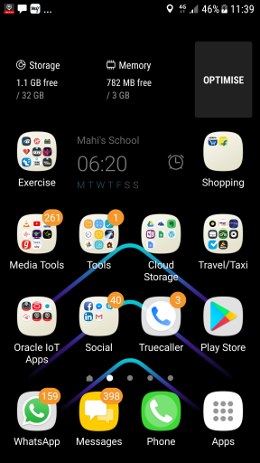

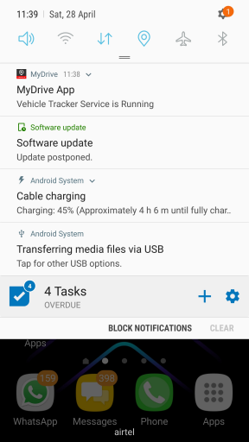

* You can go back to the main application ‘MyDrive’ by clicking on the notification. Whenever you want to stop the service, you may do so either by clicking the STOP SERVICE button shown in the notification (you may need to expand the notification to see this button) or by clicking the STOP SERVICE button in the main application itself.

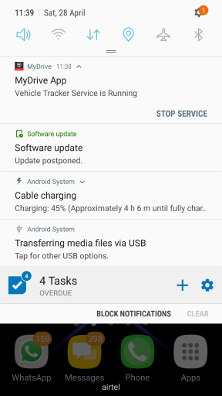

* If everything has gone well so far, the mobile phone would have activated 2 devices with the IoT Cloud instance.
* Go the IoT FM Cloud web app and create a Vehicle (name it as <your> Car, so that you can identify it easily later) for the vehicle type you had created earlier.
* For the Speed and Odometer sensor attributes, associate the Vehicle Sensor device and for the other attributes the Cargo Sensor device. You are all set to now take the app for a ride…..actual ride, I mean.
* You may STOP the service and kill in the MyDrive app now.
* About the logging feature – You could log the data locally to your mobile phone by clicking ‘START LOG’ button. This will create a csv file in a subfolder viz MyDrive in the internal storage of the android mobile. You could use this feature to verify the correctness of the data reported to IoT Cloud. However, note that the logging features logs a large amount of data in quick time and hence it should be used appropriately. Also note that the logging works only when the main application is running in the foreground i.e. it will stop logging if MyDrive app is sent to background or if you turn off the mobile device screen.

### In your car

* Place the mobile phone according to the **chosen orientation setting, with the screen facing the driver**, in a firm mobile device holder in your car. The app does not (yet) support the orientation dynamically. It may….in future ☺
* Once you are ready to start your trip, launch the IoT FM mobile app (the existing IoT FM Enterprise Mobile app) on your mobile phone and log in.
* Pick the appropriate Vehicle for your trip. Yes, it’s the same vehicle that you had created in the IoT FM Cloud earlier.
* If you have created a trip template earlier in IoT FM cloud instance, you may chose that trip template or you could create a custom trip and click the Start Trip button in the IoT FM Mobile app.
* In your phone, launch the MyDrive application and click the START SERVICE Button.
* And……………..start driving. Drive safe and don’t look at the mobile screen when you are driving. As I said earlier, the app runs in the background even if your mobile screen is turned off.
* After you reach your destination, click the ‘Complete Trip’ button in the IoT FM Mobile app and also the STOP SERVICE button in MyDrive app. You are done with the on field part!!!

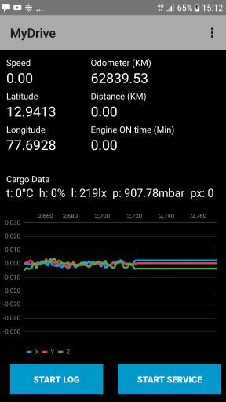

### Verify the trip data on IoT FM Cloud

* Go to IoT FM Cloud webapp.
* You would see a trip created for your recent drive. See the details of the trip – trip details and the map view.
* You could also check the driver score by going to the driver details page (feature to be available in 18.3.3)

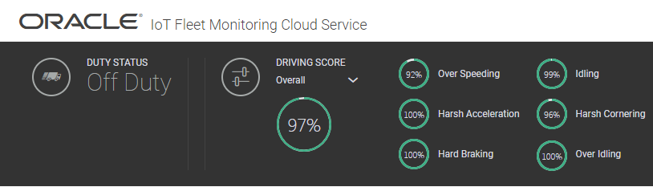

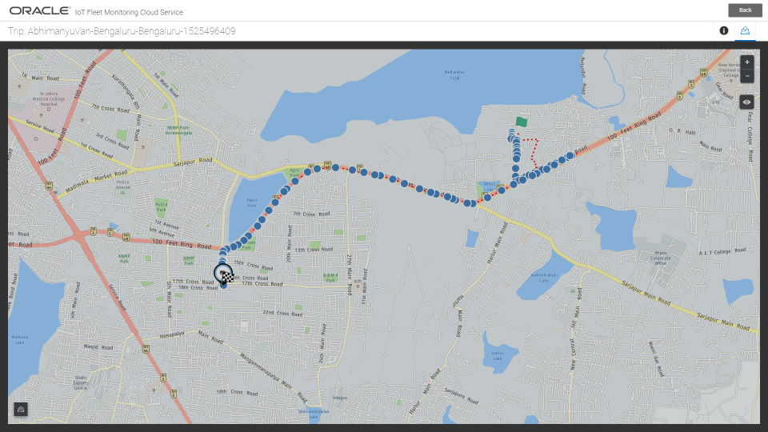

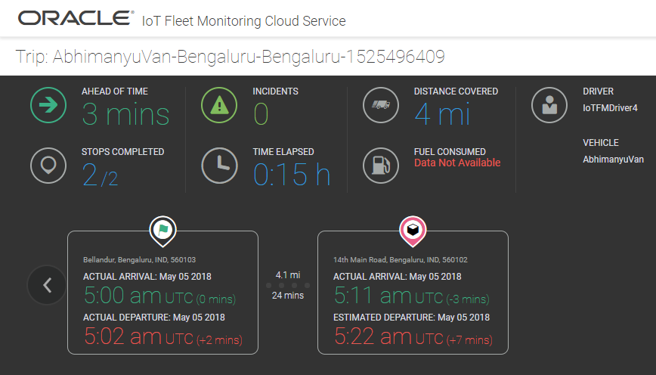

I hope you had an exciting trip!!!!

If not, file all the issues as bugs ☺……not on the MyDrive app but the relevant aspects of the IoT FM Cloud app!!!!